**USER MANUAL**

**Introduction:-**

This manual will help you in understanding how the tool will work in order to create code for Text highlighter of the text you want.

This manual is for Kinesis and ConfirmIT users both. Below are the steps and explanation of the same that you need to follow.

*Note:-* ***ConfirmIT*** *Users scroll to* ***page number 8****.*

**For Kinesis Tool**

**Create Single Color Text highlighter**

**Step 1-**

Create a checkbox question, with options as words of the text, for which you want to create a text highlighter.

For example, we are considering text as given below:-

**This is a text highlighter tool for a single color. Showing a demo, how the tool will work for a single color text highlighter.**

**,** now the options of checkbox question will be as given below

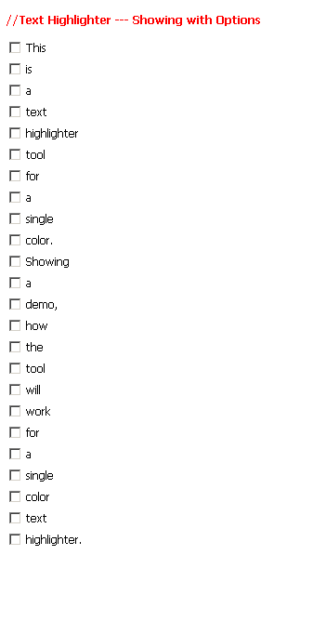

**Step 2-**

Now using the tool:-

* Select tool option as “Kinesis”.
* Paste the text in the tool, in our case text is [**This is a text highlighter tool for a single color. Showing a demo, how the tool will work for a single color text highlighter.**].
* Enter the question ID in “**Enter Question ID:”** text box, the question you created as checkbox in Step 1. In our case question ID is “**QTH1**”.

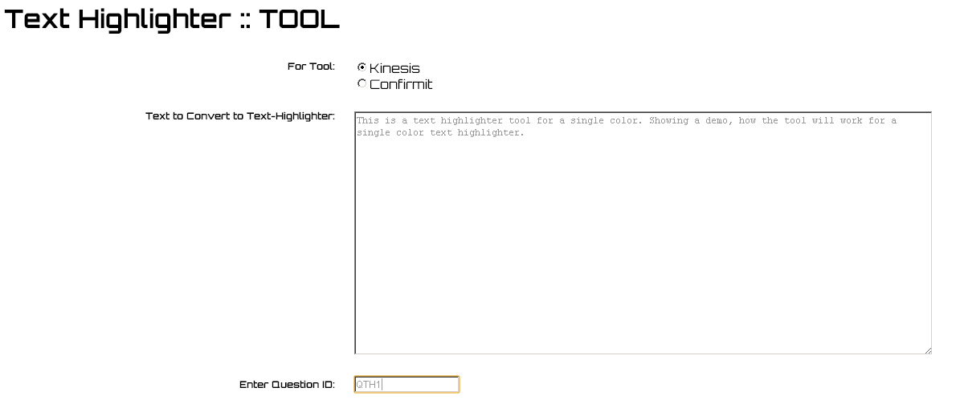

* Now click on  button and a pop up will open with all the code you need for text highlighter.

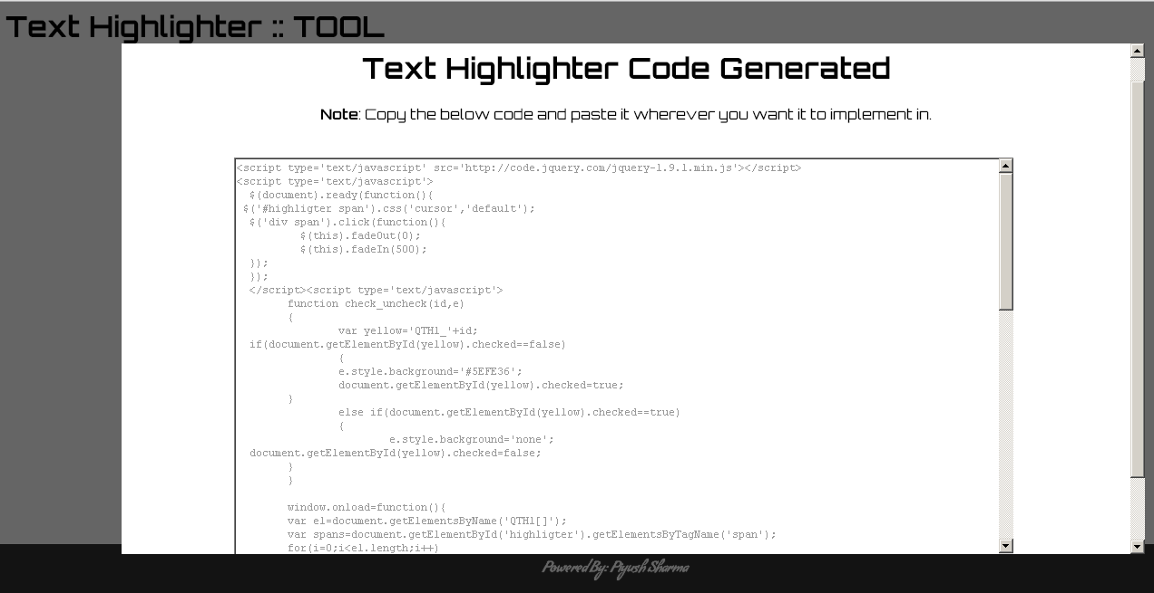

**Step 3-**

Go back to Kinesis,

* Check the question in which you have to insert Text Highlighter, in our case **QTH1.** And create a CUSTOM HTML RANGE on it.
* Now insert the code which is generated by the tool into CUSTOM HTML and save it.

**NOTE:-** Do not remove below code from CUSTOM HTML which is provided when you have created the CUSTOM HTML. If, removed copy the below code and paste it at the end of your code.

**<!-- THESE FIELDS ARE REQUIRED --> <input type="hidden" name="sessionstr" value="%SESSIONSTR%"><input type="hidden" name="pagenum" value="%PAGENUM%"> <!-- CONTROL BUTTONS --> %BACK% %CONTINUE%**

**YOUR TEXT HIGHLIGHTER IS READY NOW!!!**

**TAKE A RUN OF THE SURVEY!!** ☺

**Create Dual Color Text highlighter**

**Step 1-**

Create two checkbox questions, with options as words of the text, for which you want to create a text highlighter.

For example, we are considering text as given below:-

**This is a text highlighter tool for dual color. Showing a demo, how the tool will work for dual color text highlighter.**

**,** now the options of both checkbox questions is given below

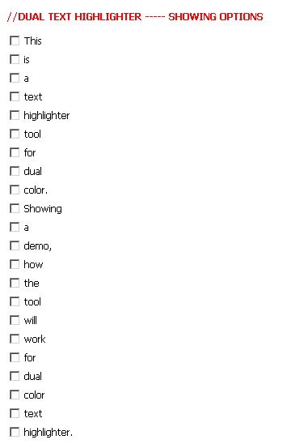

**Step 2-**

Now using the tool:-

* Select tool option as “Kinesis”.

Paste the text in the tool, in our case text is [**This is a text highlighter tool for dual color. Showing a demo, how the tool will work for dual color text highlighter.**].

* Enter your Ist color question ID in “**Ist Color Question Id:”** textbox, in our case “**QTH1**” and IInd color question ID in “**IIst Color Question Id:**” textbox, in our case “**QTH2**”.

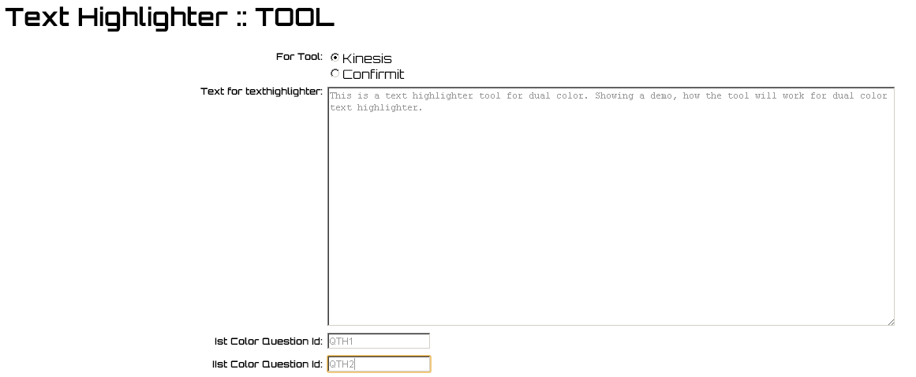

* Now click on  button and a pop up will open with all the code you need for text highlighter.

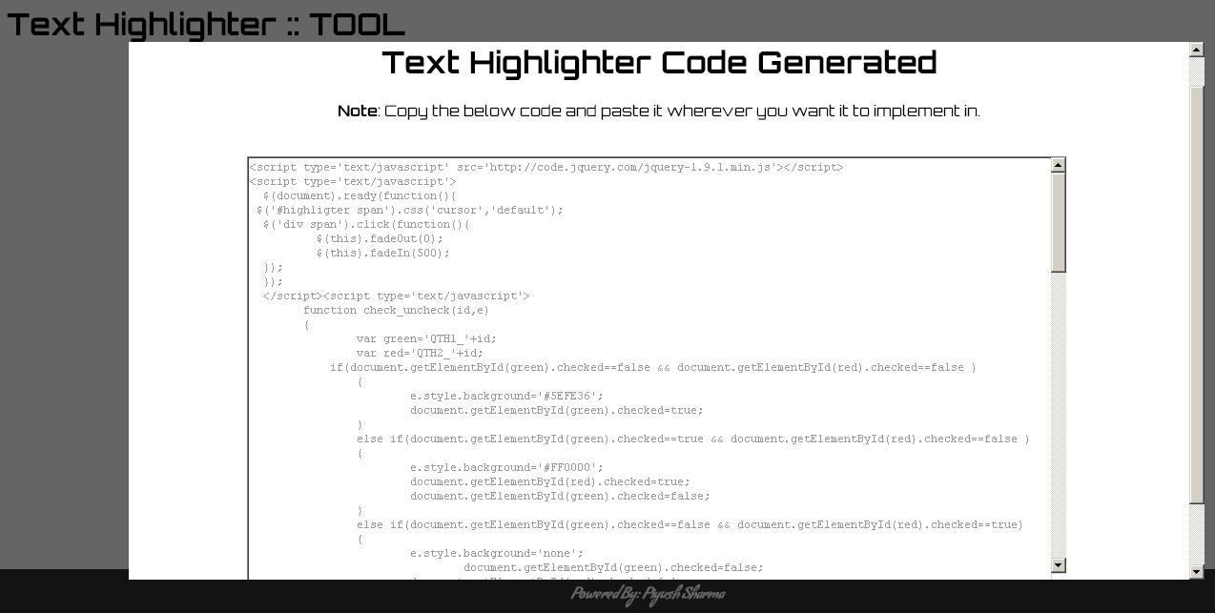

**Step 3-**

Go back to Kinesis,

* Check both questions in which you have to insert Text Highlighter, in our case **QTH1** and **QTH2.** And create a CUSTOM HTML RANGE on it.
* Now insert the code which is generated by the tool into CUSTOM HTML and save it.

**NOTE:-** Do not remove below code from CUSTOM HTML which is provided when you have created the CUSTOM HTML. If, removed copy the below code and paste it at the end of your code.

**<!-- THESE FIELDS ARE REQUIRED --> <input type="hidden" name="sessionstr" value="%SESSIONSTR%"><input type="hidden" name="pagenum" value="%PAGENUM%"> <!-- CONTROL BUTTONS --> %BACK% %CONTINUE%**

**YOUR DUAL TEXT HIGHLIGHTER IS READY NOW!!!**

**TAKE A RUN OF THE SURVEY!!** ☺

**For ConfirmIT Tool**

**Create Single Color Text highlighter**

**Step 1-**

Create an info question first.

Now using the tool:-

* Select tool option as “Confirmit”.
* Paste the text in the tool, in our case text is [**This is a text highlighter tool for a single color. Showing a demo, how the tool will work for a single color text highlighter.**].
* Enter the question ID in “**Enter Question ID:”** text box, the question you would be creating to store the highlighted text. In our case question ID is “**q1**”.

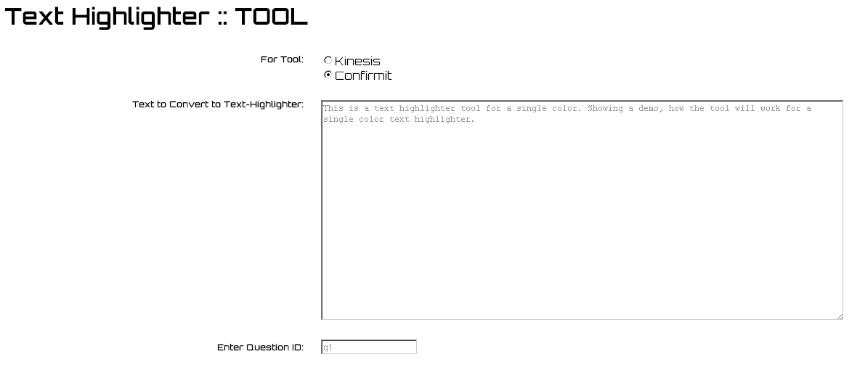

* Now click on  button and a pop up will open with all the code you need for text highlighter.

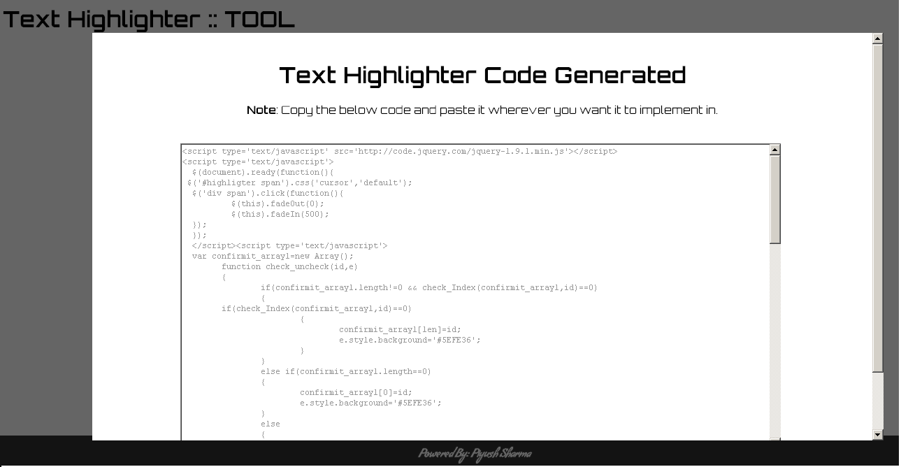

* Copy and paste the code appeared in pop up into the “Text” area given in Info node created. Save it.

**Step 2-**

Now after info question, create a **Multi** question, with options as words of the text, for which you want to create a text highlighter.

For example, we have considered the text as given below:-

**This is a text highlighter tool for a single color. Showing a demo, how the tool will work for a single color text highlighter.**

**,** now the options of checkbox question will be as given below

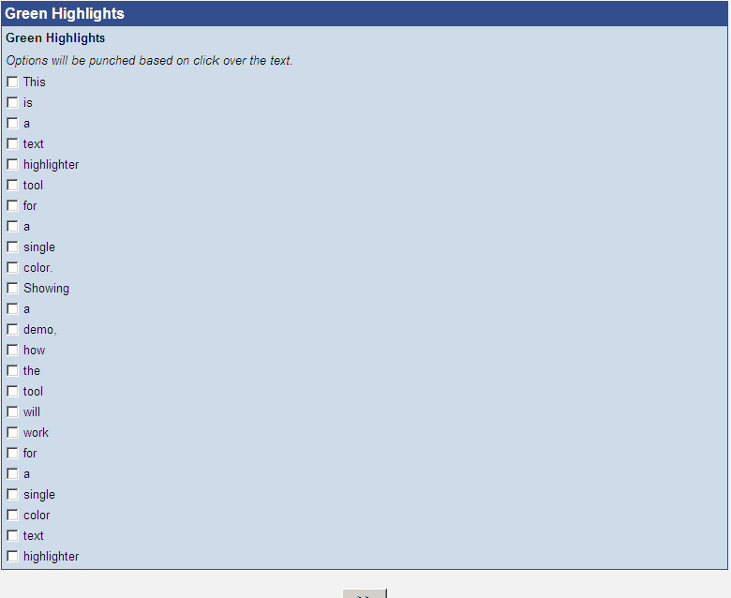

**Step 3-**

* Now add a “**Script**” node between the info question and multi question created above.
* Now write a script in it to get precodes from a text element named “**values**”[which is coming from info question and it has the precodes of words highlighted by a respondent for eg., “values” will have a value like 10,15,22,25.], and punch these precodes in the multi question created after.

In our case the script will be like as below:-

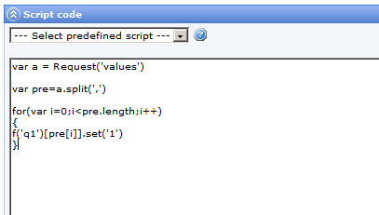

In above script, “values” is coming from info node/question.

‘q1’ in **f(‘q1’)[pre[i]].set(‘1’)** is the question ID of multi question created.

Save it.

**YOUR TEXT HIGHLIGHTER IS READY NOW!!!**

**TAKE A RUN OF THE SURVEY!!** ☺

**Note:**-

*While setting the study LIVE, set the multi question as “Hidden” from properties.*

*Also, set the text element “values” in info question as hidden by replacing*

***<input type='text' name='values' value='' id='values' size='50'>***

*with*

***<input type='hidden' name='values' value='' id='values' size='50'>***

**Create Dual Color Text highlighter**

**Step 1-**

Create an info question first.

Now using the tool:-

* Select tool option as “Confirmit”.
* Paste the text in the tool, in our case text is [**This is a text highlighter tool for a dual color. Showing a demo, how the tool will work for dual color text highlighter.**].
* Enter both the question ID’s in “**Ist Color Question Id:”** and **“IInd Color Question Id:”** text box, the questions you would create for storing highlighted text. In our case question ID is “**q1**” and “**q2**”.

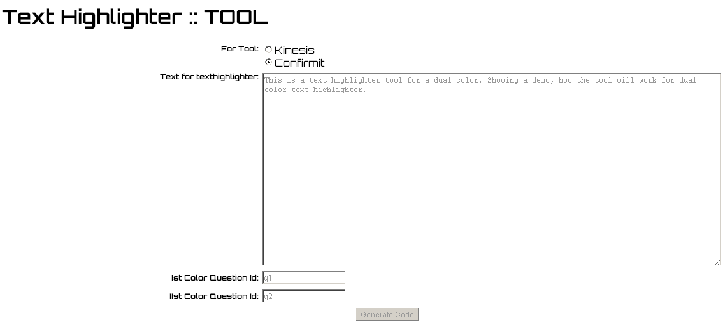

* Now click on  button and a pop up will open with all the code you need for text highlighter.

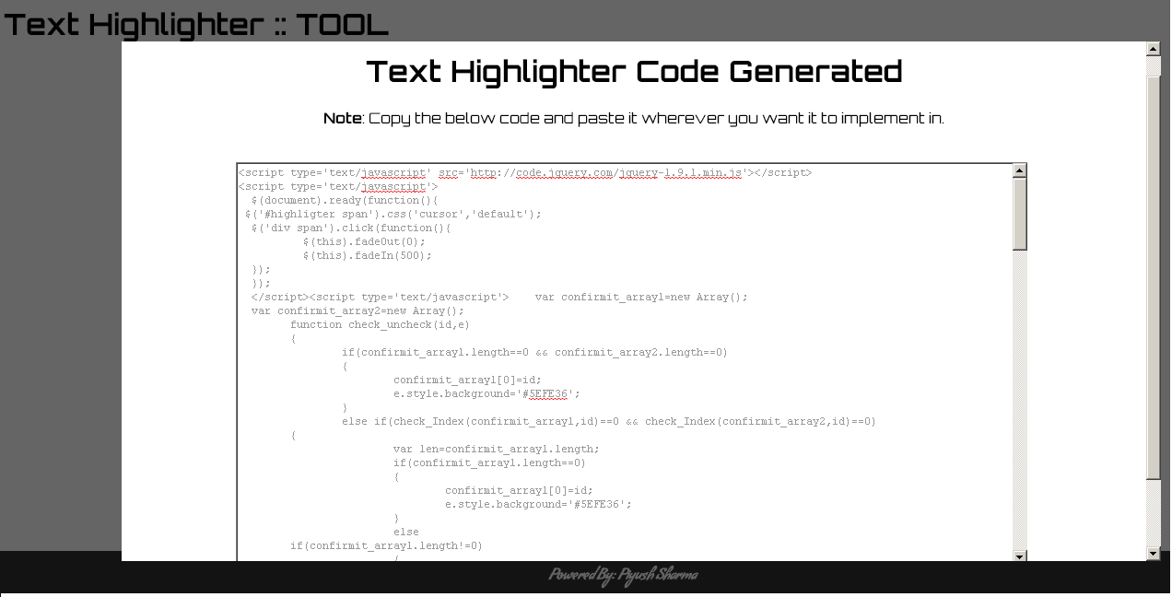

* Copy and paste the code appeared in pop up into the “Text” area given in info node created. Save it.

**Step 2-**

Now after info question, create two **Multi** questions (one question, in our case q1, for punching single clicked text and another one, in our case q2, for punching double clicked text), with options as words of the text, for which you want to create a text highlighter.

For example, we have considered text as given below:-

**This is a text highlighter tool for a dual color. Showing a demo, how the tool will work for dual color text highlighter.**

**,** now the options for both the checkbox questions will be as given below

**Snapshot of q1**

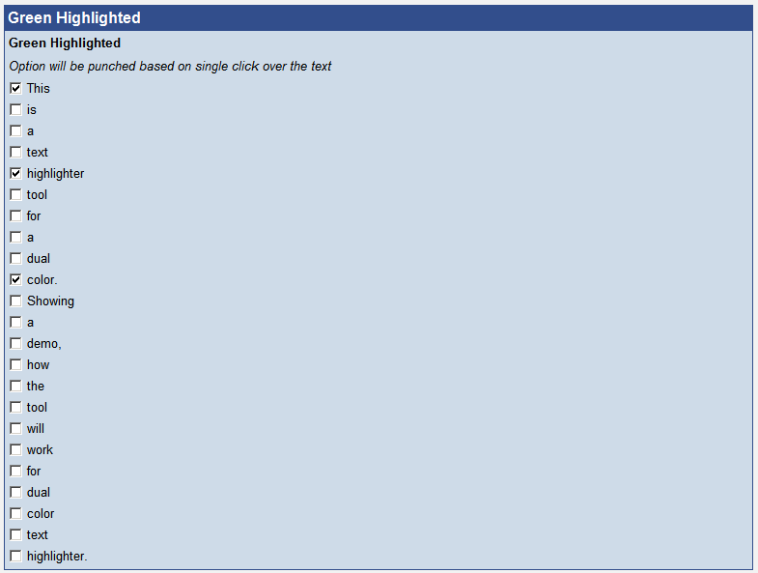

**Snapshot of q2**

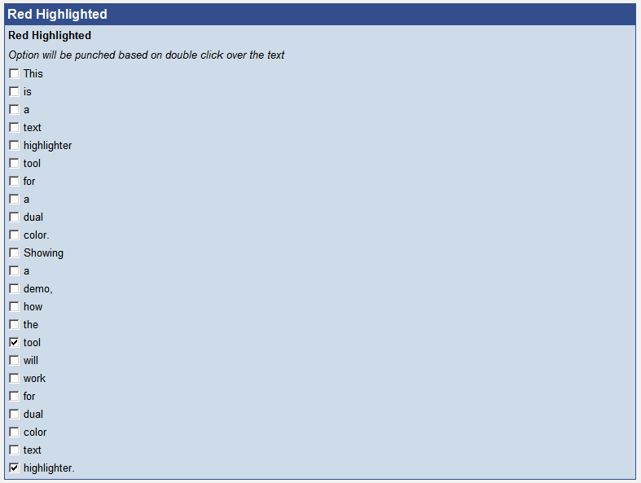

**Step 3-**

* Now add a “**Script**” node between the info question and multi questions created above.
* Now write a script in it, to get precodes from a text elements named “**values1**” and “**values2**”[which are coming from info question and it has the precodes of words highlighted by a respondent for eg., “**values1**” will have a value like 10,15,22,25.], and punch these precodes received from “**values1**” (single clicked text) in the multi question **q1** and punch precodes received from “**values2**” (double clicked text) in multi question **q2**.

In our case the script will be like as below:-

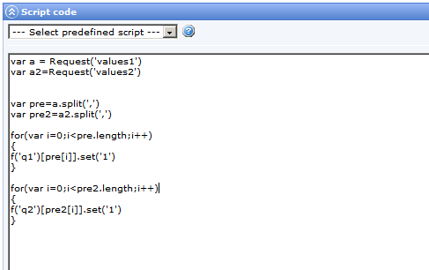

In above script, “values1” and “values2” is coming from info node/question.

‘q1’ in **f(‘q1’)[pre[i]].set(‘1’)** is the question ID of multi question created for single clicked text.

‘q2’ in **f(‘q2’)[pre2[i]].set(‘1’)** is the question ID of multi question created for double clicked text.

Save it.

**YOUR TEXT HIGHLIGHTER IS READY NOW!!!**

**TAKE A RUN OF THE SURVEY!!** ☺

**Note:**-

*While setting the study LIVE, set both the multi questions as “Hidden” from properties.*

*Also, set the text element “values1” and “values2” in info question as hidden by replacing*

***<input type='text' name='values1' value='' id='values1' size='50'>***

***<input type='text' name='values2' value='' id='values2' size='50'>***

*with*

***<input type='hidden' name='values1' value='' id='values1' size='50'>***

***<input type='hidden' name='values2' value='' id='values2' size='50'>***

*Last thing to do is to hide heading in Info question above text boxes i.e. “***Green Highlights”** and **“Red Highlights”**. *Insert a style property in h4 tag as* ***<h4 style=”display:none”>.***